**Project Proposal**

1. Name of the Project
2. Motivation or Impact (Why have you selected this project?)
3. Features (3.1, 3.2, 3.3…) [At least one innovative feature]
4. UI design

Page 1:

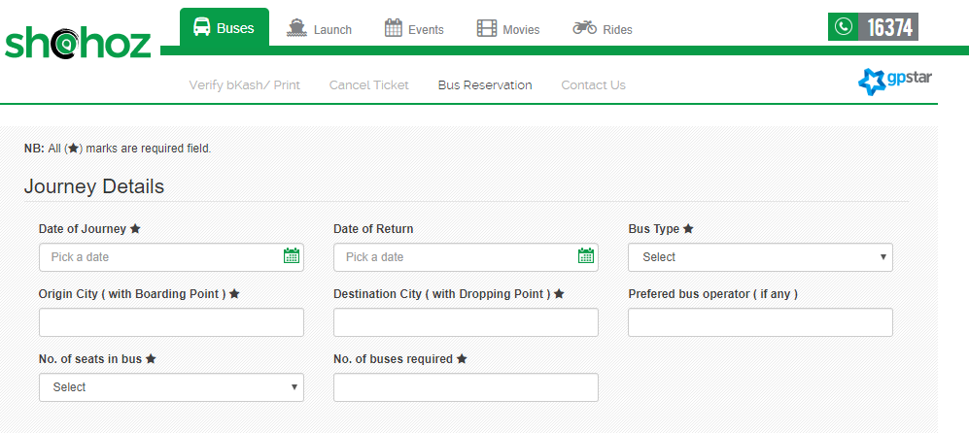

Page 2:

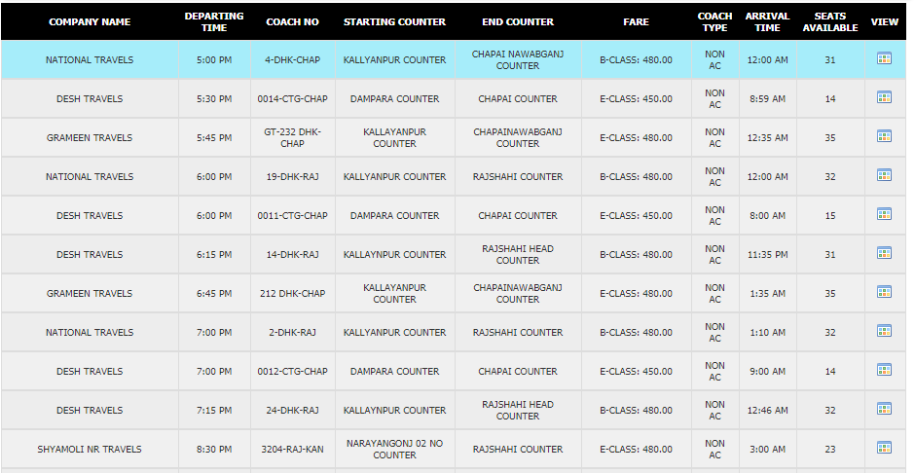

Page 3:

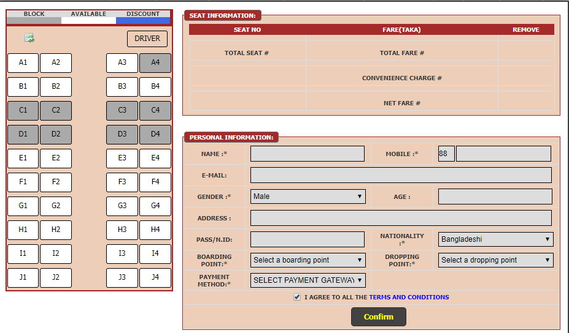

Page 4:

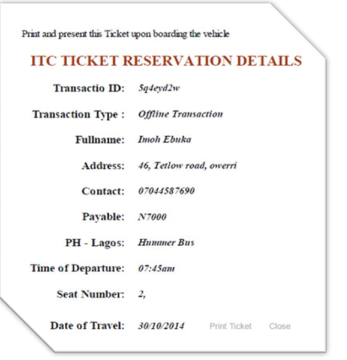

1. Break down in time (weekly update)

Week 1:

Week 2:

……

Week 10:

1. Conclusion:

Notes:

1. Project proposal presentation
2. Presentation duration: 10 min (5 min + 5 min)
3. Presentation language English
4. Dress code: Formal
5. Bonus mark for asking critical questions after the presentation
6. Negative mark for disturbing during presentation
7. Submit project proposal before the deadline in Google classroom.